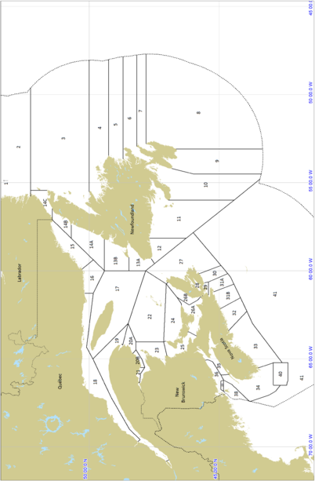 \Figure{Map of the Lobster Fishing Areas in Atlantic Canada using the boundaries identified in the Atlantic fishery regulations.}

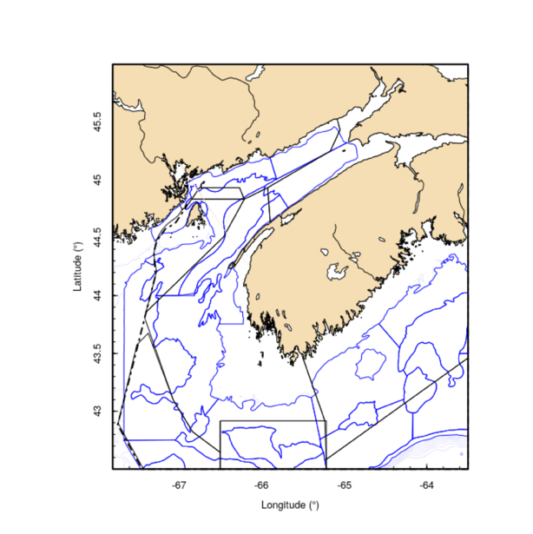 \Figure{Strata map (blue lines) for DFO summer research vessel surveys in LFAs 34-38 (black lines).}

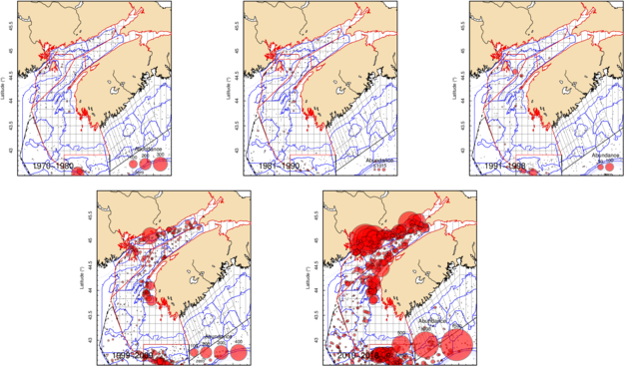

\Figure{Map of the abundance of lobster captured during DFO's summer RV survey of the Scotian Shelf. Strata boundaries are outlined in blue and LFA boundaries are outlined in black. Size of the symbols are scaled to the number observed within each tow.}

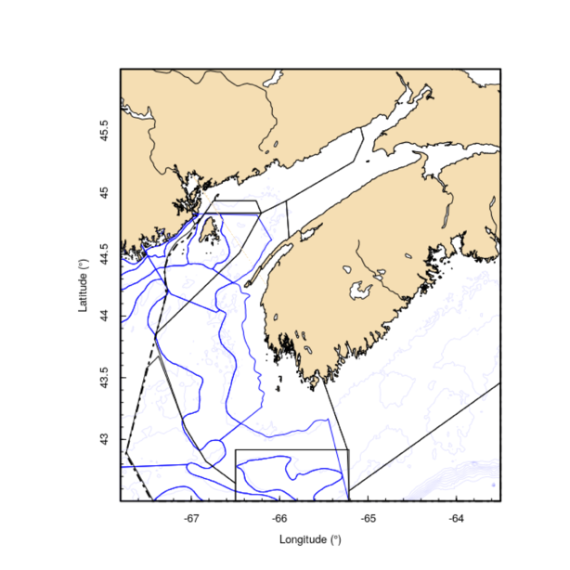

\Figure{Strata map (blue lines) for NEFSC spring and fall research vessel surveys in LFAs 34-38 (black lines).}

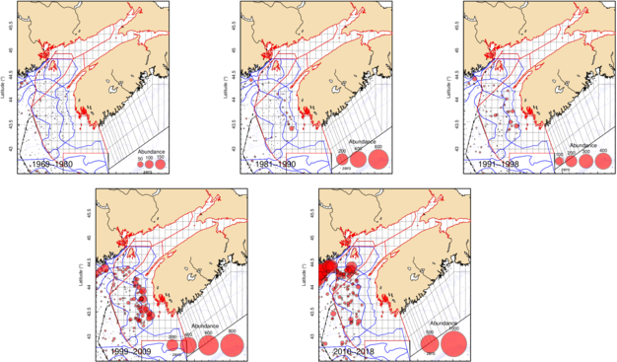

\Figure{Map of the abundance of lobster captured during NEFSC spring RV survey of the Scotian Shelf. Strata boundaries are outlined in blue and LFA boundaries are outlined in black. Size of the symbols are scaled to the number observed within each tow.}

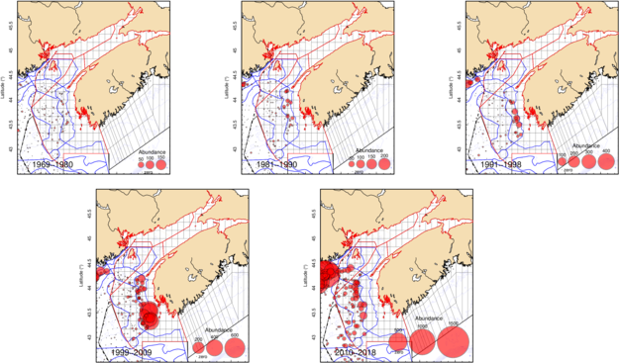

\Figure{Map of the abundance of lobster captured during NEFSC fall RV survey of the Scotian Shelf. Strata boundaries are outlined in blue and LFA boundaries are outlined in black. Size of the symbols are scaled to the number observed within each tow.}

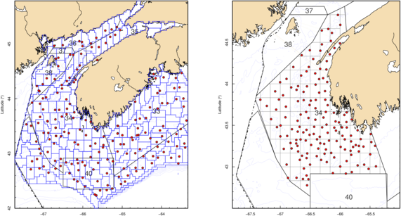

\Figure{Maps of the fixed gear survey stations from the ITQ survey (left) and the ILTS survey (right).}

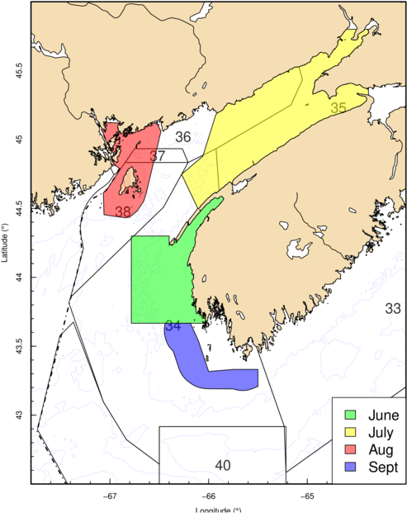

\Figure{Map of the outer boundaries for the inshore scallop surveys with the month of year that the survey is conducted.}

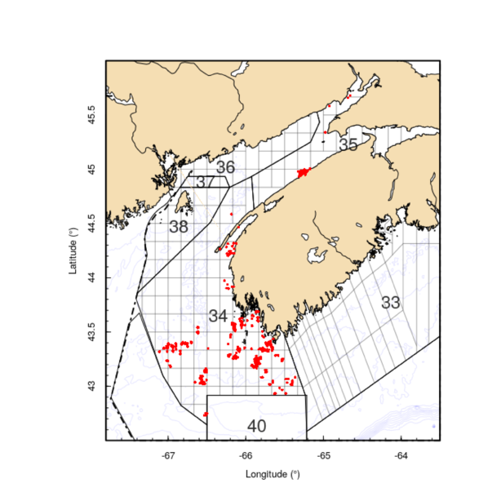 \Figure{Trap sampling locations for FSRS recruitment traps between 2015 and 2018 in LFA 34 - 38.}

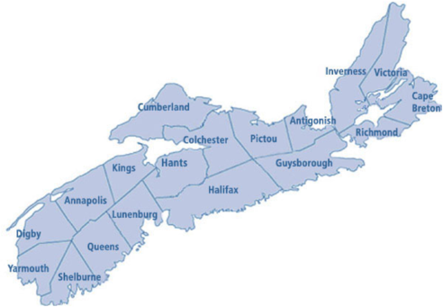

\Figure{Map of the counties in Nova Scotia used for splitting the historic landings information for LFA 34 (Yarmouth and Digby county).}

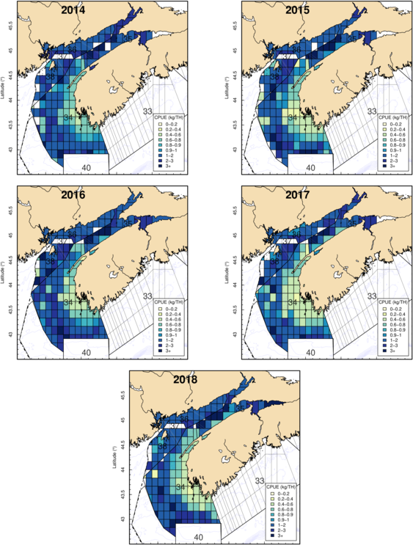 \Figure{Map of the fishery footprint expressed as the commercial catch rates in each grid of LFAs 34 - 38 from 2014-2018.}

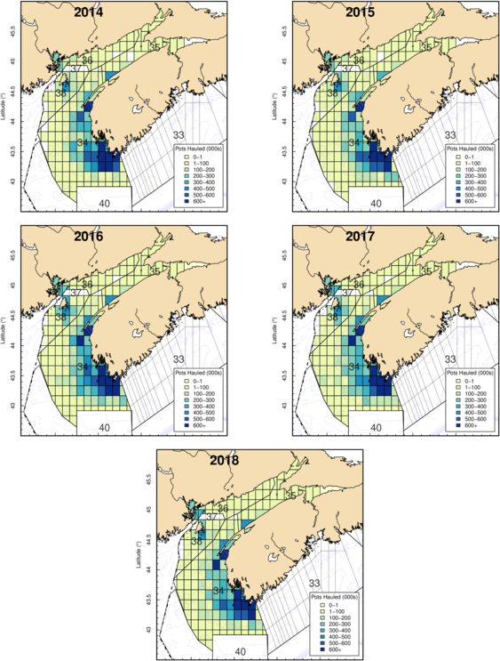

\Figure{Map of the fishery footprint expressed as the numbers of trap hauls in each grid of LFAs 34 - 38 from 2014-2018.}

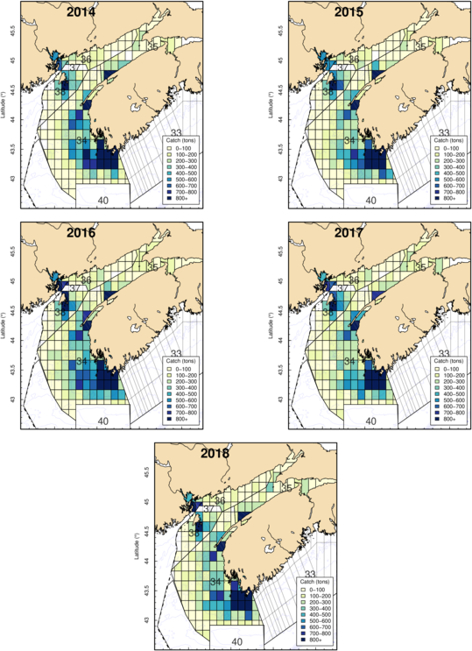 \Figure{Map of the fishery footprint expressed as the weight of landings in each grid of LFAs 34 - 38 from 2014-2018.}

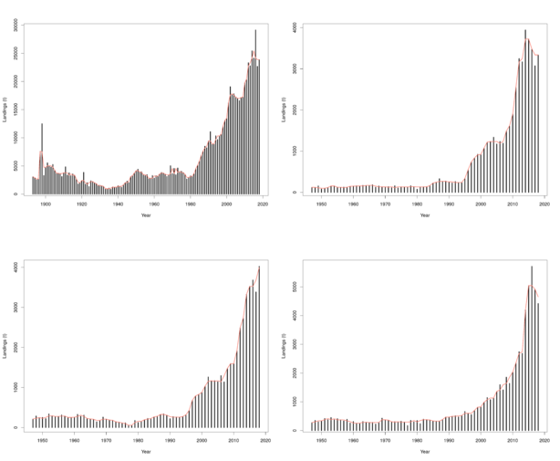\Figure{Landings trends by LFA for each of LFA 34-38. Red lines represent the three year running medians within each plot. Clockwise from top left, LFA 34, LFA 35, LFA 38, LFA 36. In LFA 34 landings prior to 1947 were split into LFAs by county as indicated in Figure 10. }

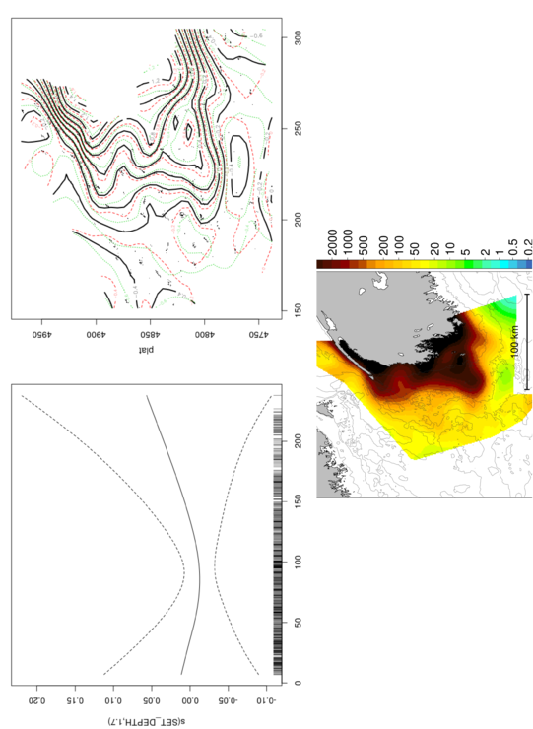 \Figure{Plots of the smooth depth and spatial terms of the total abundance generalizied addtive model for the ILTS trawl survey (top). Predicted surface of lobster abundance within LFA 34 from the selected gam model for 2018.}

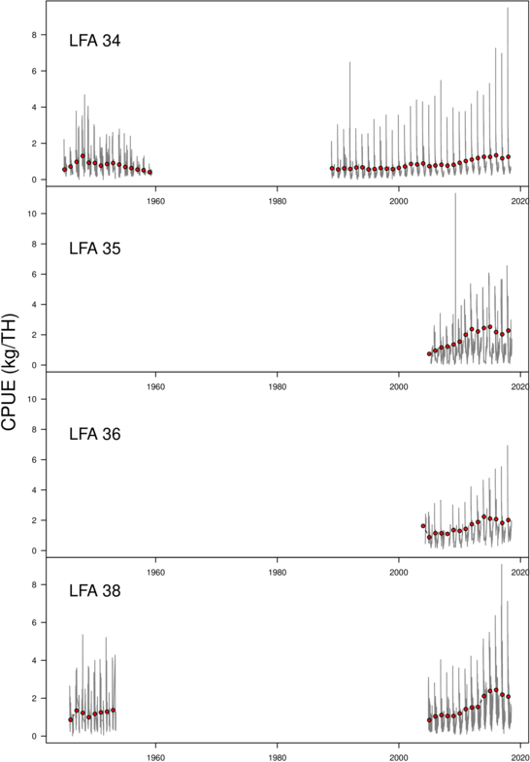 \Figure{Daily (grey line) and Annual (red dot) mean Catch per unit effort (kg/Trap Haul) for each LFA.}

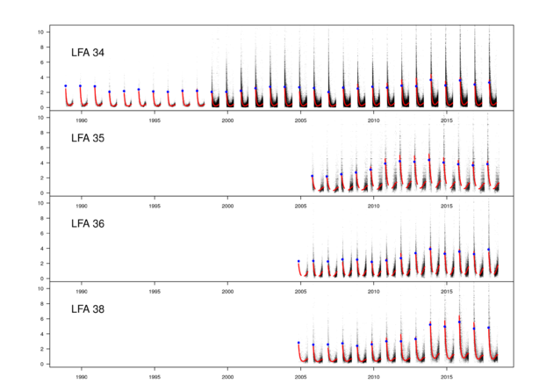 \Figure{Predictions of Catch per unit effort (kg/trap haul) from the model for each day (red line), overlaid on the raw data for LFAs 34-38. }

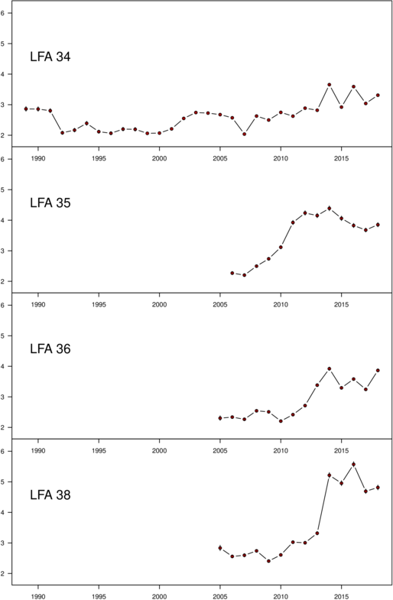\Figure{The model predicted mean and standard deviation (covered by points) Catch per unit effort (CPUE) indices for each LFA. }

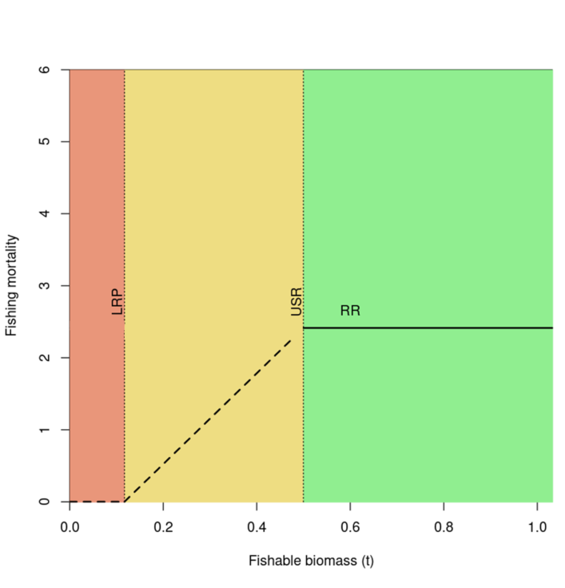 \Figure{Example precautionary approach phase plot delimiting the healthy zone (green) above upper stock reference (USR) the cautious zone (yellow), between the USR and the limit reference point (LRP) and critical zone (red), below the LRP. The removal reference (RR) is shown as a solid black line in the healthy zone and progressively decreasing through the cautious zone, the shape and rate of decrease was shown as an example.}

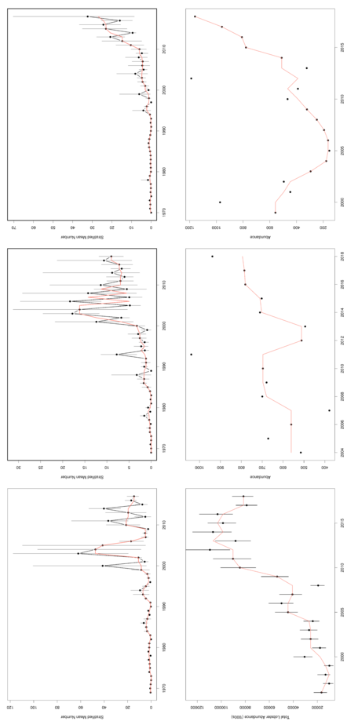 \Figure{Plot of the total abundance indices of lobsters in LFA 34. Clockwise from top left, NFall, NSpr, DFO, SFA29, SPA3, and ILTS.

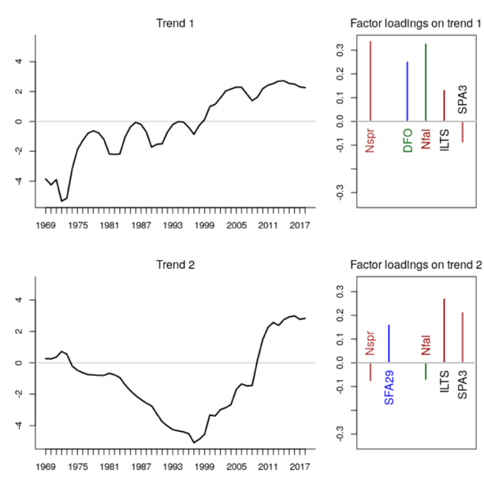

\Figure{Time series states in LFA 34 total lobsters estimated from Dynamic Factor analyses of the six abundance trends.}

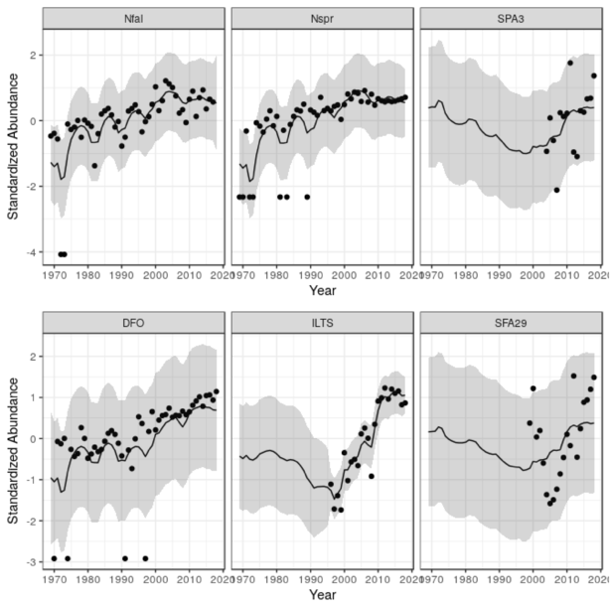 \Figure{Time series trend fits with confidence intervals from Dynamic Factor analyses of the six abundance trends.}

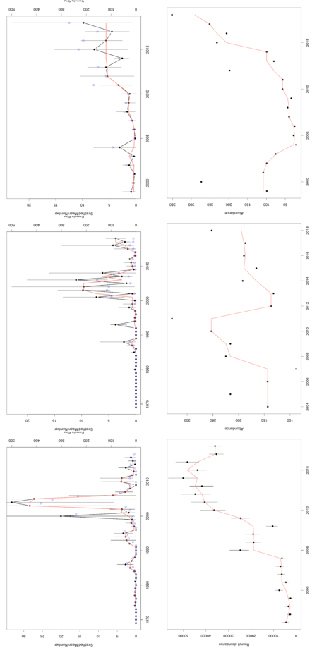 \Figure{Plot of the recruit abundance indices of lobsters in LFA 34. Clockwise from top left, NFall, NSpr, DFO, SFA29, SPA3, and ILTS.

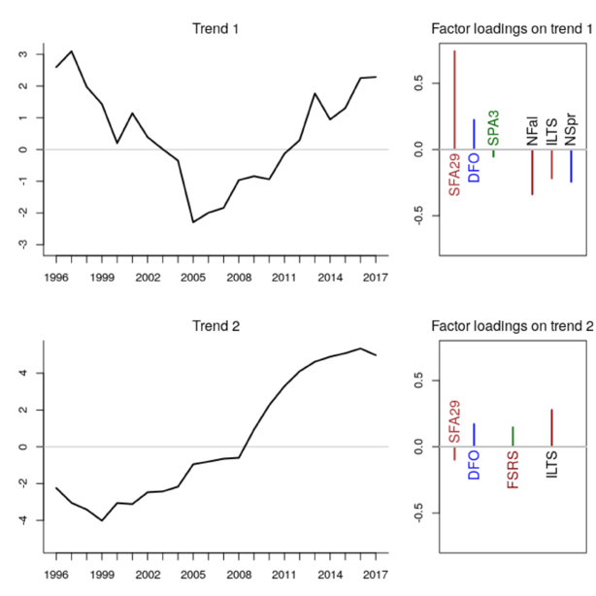 \Figure{Time series states in LFA 34 recruiting lobsters estimated from Dynamic Factor analyses of the seven abundance trends.}

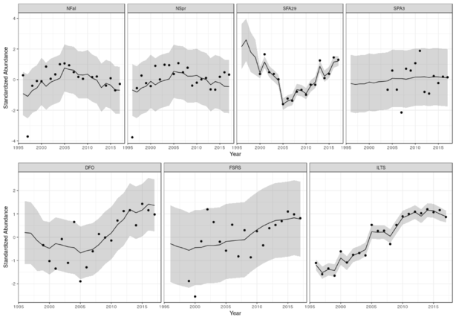 \Figure{Time series trend fits with confidence intervals from Dynamic Factor analyses of the seven abundance trends.}

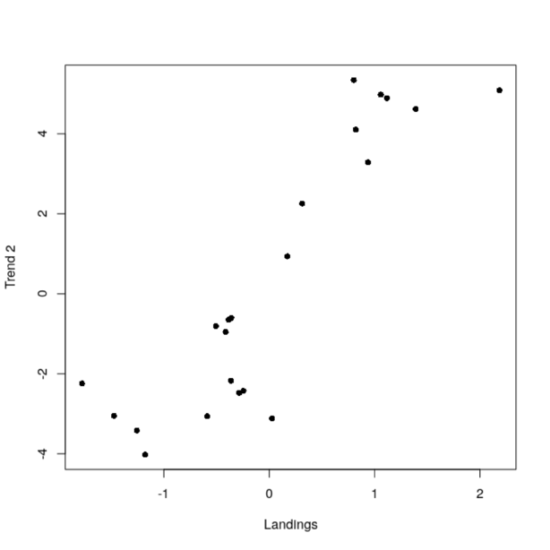 \Figure{Plot of DFA time trend 2 of recruit abundance in LFA 34 to landings in the following year.}

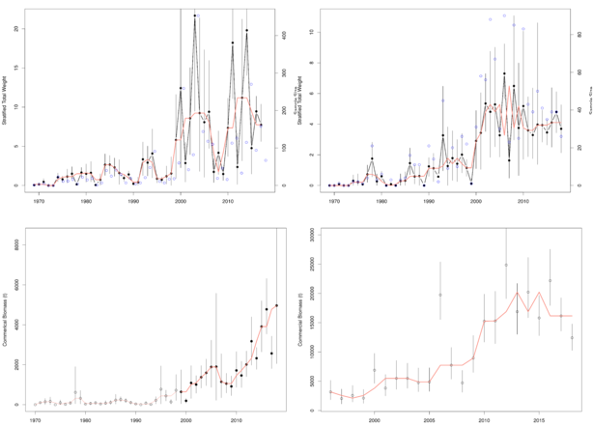 \Figure{Time series trends in commercial biomass for lobsters within LFA 34 captured in trawl surveys. Clockwise from top left, NFall, NSpr, ILTS and DFO.

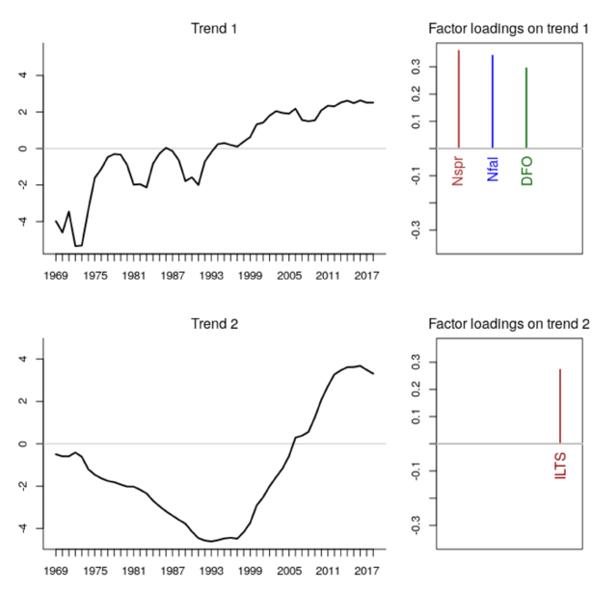 \Figure{Time series states in LFA 34 commercial biomass trends estimated from Dynamic Factor analyses.}

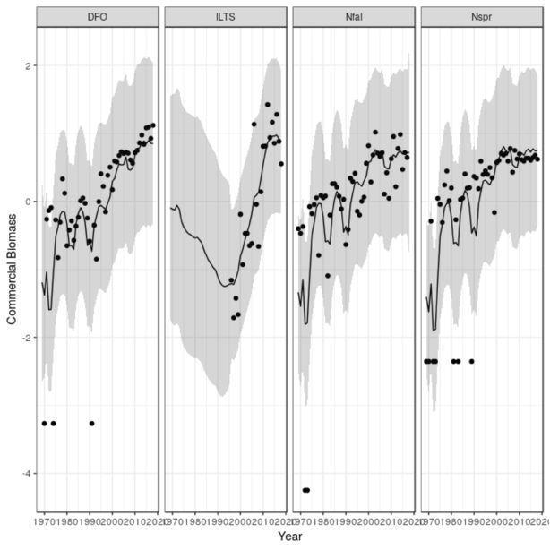 \Figure{Time series trend fits with confidence intervals from Dynamic Factor analyses of the commercial abundance trends.}

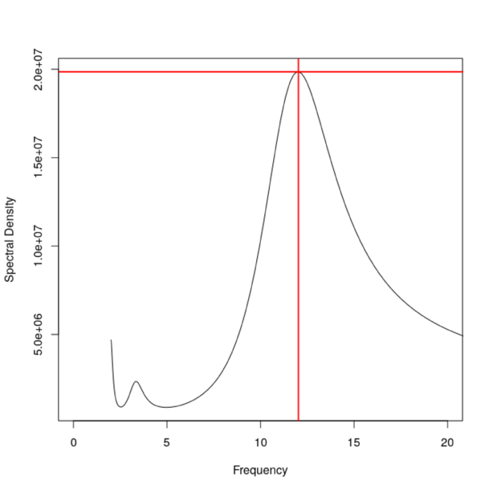 \Figure{Spectral density of detrended landings data from LFA 34 to determine the frequency of the cyclic pattern observed in the data.}

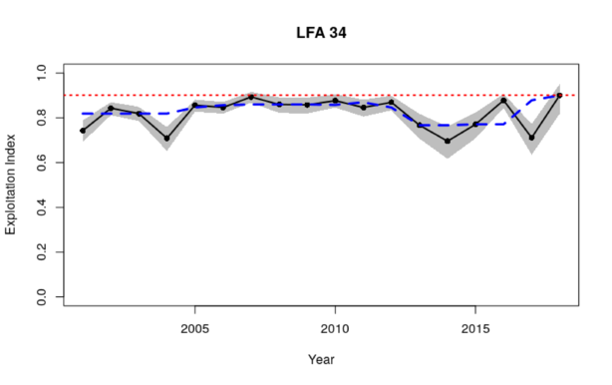 \Figure{Exploitation indicies for LFA 34 derived using the change in ratio (CCIR) method on the FSRS recruitment trap data.}

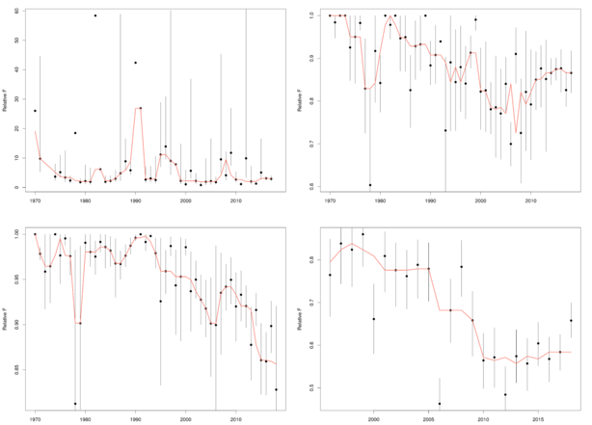\Figure{Time series trends of relative fishing mortality using observed landings and survey estimated commercial biomass for lobsters within LFA 34. Clockwise from top left, NFall, NSpr, ILTS and DFO. Orange lines represent three year running medians.}

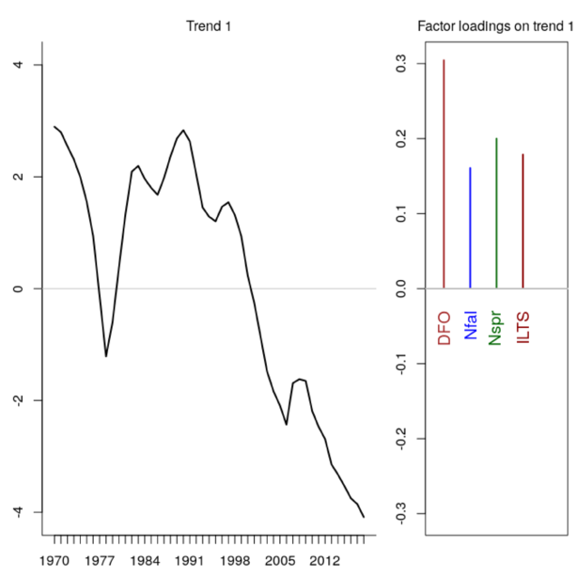 \Figure{Time series states in LFA 34 relative fishing mortality and CCIR exploitation from Dynamic Factor analyses.}

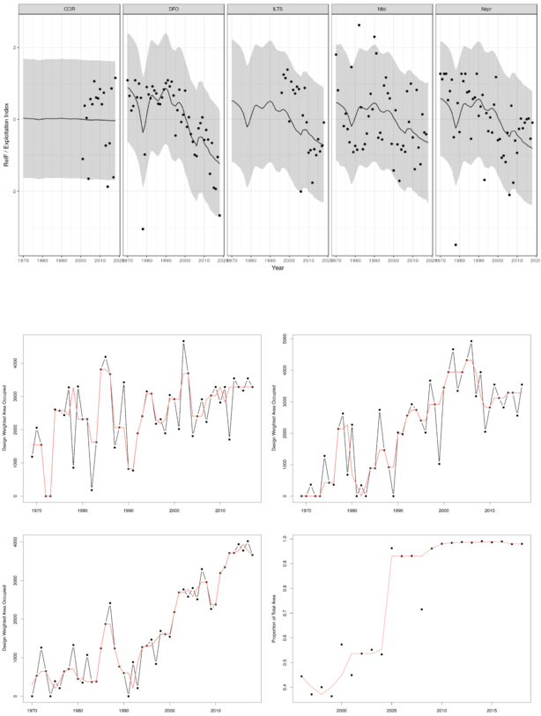 \Figure{Time series trend fits with confidence intervals from Dynamic Factor analyses of the relative fishing mortality and CCIR exploitation indices in LFA 34.}

 \Figure{Plot of the area occupied of lobsters within LFA 34 captured during surveys. Clockwise from top left, NFall, NSpr, ILTS, DFO.

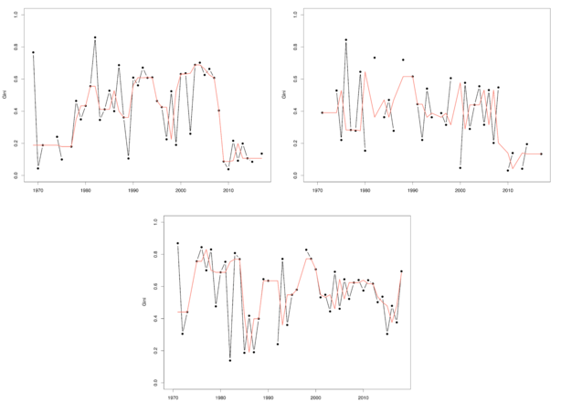 \Figure{Plot of the level of patchiness of survey catch rates for lobsters within LFA 34. Clockwise from top left, NFall, NSpr and DFO.

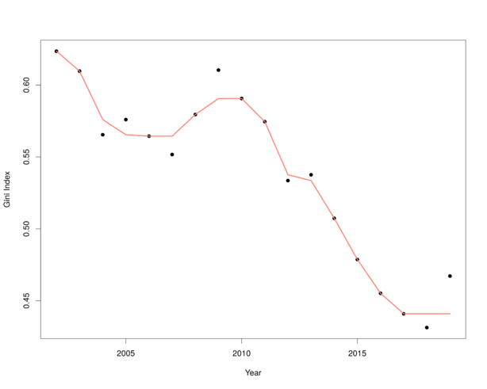

\Figure{Plot of level of patchiness of landings of lobsters within LFA 34. Patchiness was estimated by the Gini index.}

